
Year 5
This week’s learning at School and Home
Monday 15th June– Friday 19th June
English
Topic: Assessment Week

Lesson 1: Reading Paper
Lesson 2: Spelling, Grammar and Punctuation Paper

Useful Links: https://www.bbc.co.uk/bitesize/topics/z4nqfdm

Maths

Topic: Assessment Week

Lesson 1: Arithmetic Paper
Lesson 2: Reasoning Paper

Useful Links: https://www.bbc.co.uk/bitesize/subjects/zykvwsg

Science

Topic: Plant and Animal Life Cycles

Lesson 1: To describe how plants can reproduce asexually, by creating new plants from different parts of the parent plant rather than by producing seeds.

Useful Links: https://www.bbc.co.uk/bitesize/topics/zrym3qt

Key Vocabulary: propagate, below ground, potatoes, seed.

Geography

Topic: Journeys

Lesson 1: To understand that clothes can be produced fairly and sustainably, and to understand that unwanted clothing may be recycled and processed.

Useful Links: https://www.bbc.co.uk/bitesize/articles/z82djsg

Key Vocabulary: recycle, reuse, fair trade, import, export, raw material.

PSHE

Topic: Growing and Changing

Lesson 1: To identify the difference between a safe and an unsafe secret.

Useful Links: https://www.bbc.co.uk/teach/supermovers/articles/zng8vk7

Key Vocabulary: secrets, confidence, safe.

General Reminders

- PE (outdoors) takes place every Tuesday. Pupils arrive in their PE kit on this day.
- Reminder that earrings should not be worn on PE days, or alternatively tape should be placed on top of this at home.

Celebration names

- Elder Class: Amelia, for producing a delicious tasting and looking Biscoff cheesecake.
- Pine Class: Jessica, for her enthusiasm and curiosity during our science learning. She enjoyed exploring the different parts of a plant.
- Willow Class: ​​ Ashaz, for working hard in RE, listening carefully to others and sharing great ideas.
- Yew Class: Arthur, for his enthusiasm and dedication during our Pickfest rehearsals.

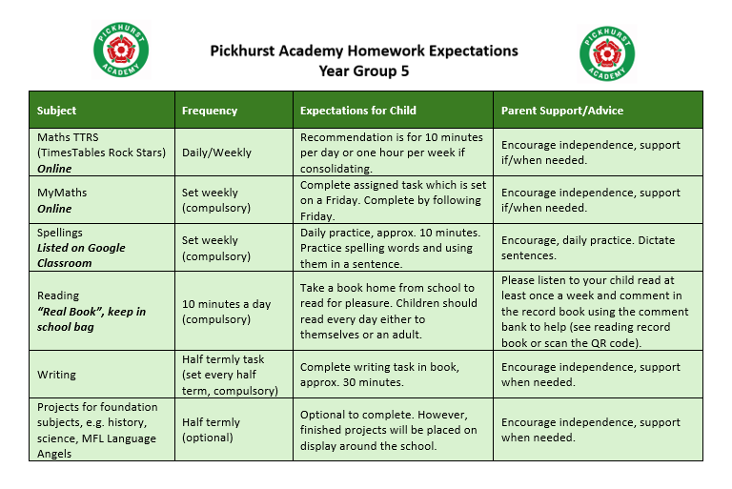Spellings

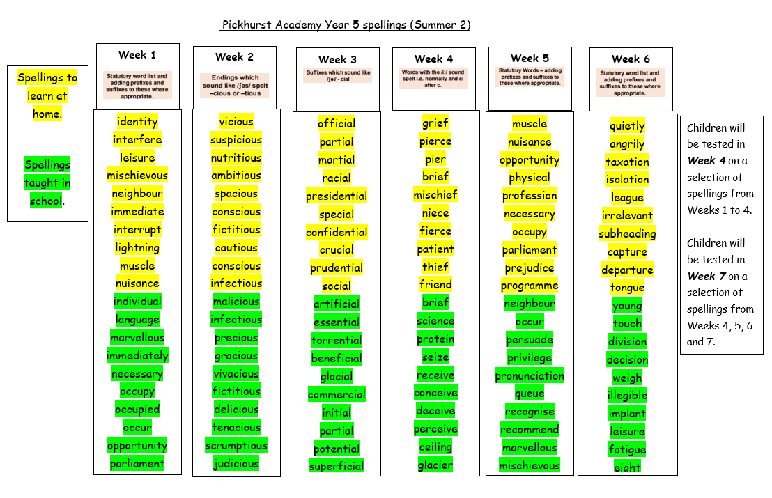

Thank you from the Year 5 team!

Pickhurst Academy is committed to safeguarding and promoting the welfare of children and young people
and expects all staff and volunteers to share this commitment.
Thank you from the Year 4 team!

